The Great Depression
Era
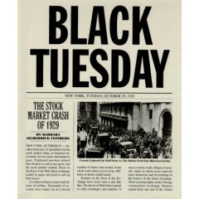
Note-Taking: Students will give a well thought out explanation for each: Chapter 21 in 5 Steps to 5 and ABC-CLIO are your resources for information
- Black Tuesday
- Dust Bowl
- Hoover’s response at the beginning of the Great Depression
- Goal of the Bonus Army
- Purpose of the Reconstruction Finance Corporation
- Differences between Hoover’s and Roosevelt’s response to Great Depression
- Explain Buying on Margin
- Franklin Roosevelt’s New Deal Programs
- Franklin Roosevelt’s Brain Trust
- Differences between the First New Deal and the Second New Deal
- Why did Huey Long and Upton Sinclair criticize the New Deal
- John Maynard Keys plan to fight the Great Depression
- What was the “Black Cabinet” during the Great Depression?
- How did Frances Perkins gain fame during the Great Depression?

