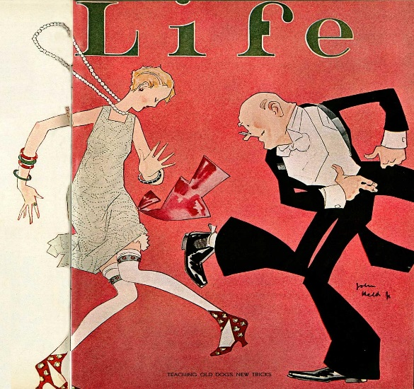
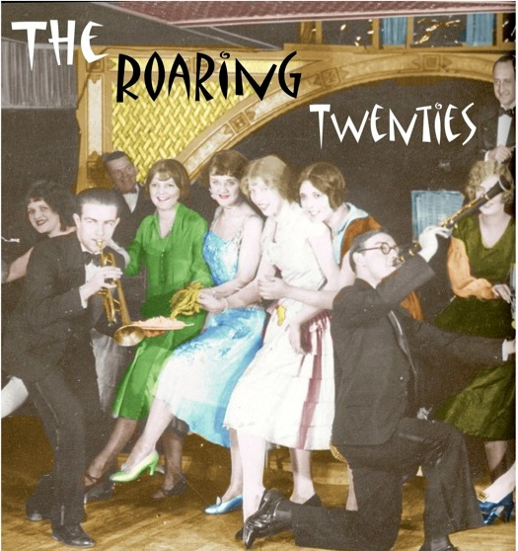
The Roaring 20s

Taking Notes:
- The Republican Administration of the 1920s:
- Palmer Raids:
- Installment Credit:
- Schenck v. United States:
- Nativism
- Harlem Renaissance
- The trial of Sacco and Venzetti
- Fordney-McCumber and Hawley-Smoot Tariffs
- Kellogg-Briand Pact
- Success of Ford Motor Company
- Purpose of the Nineteenth Amendmant
- Scopes Trial
- Teapot Dome Scandal
- The Lost Generation
- Significance of Herbert Hoover’s Presidential Election

